YEAR 2 HOME LEARNING
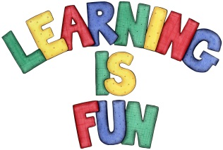
Date Set | 13.11.20
Date Due | 18.11.20
Mathletics | On Matheletics focus on subtraction and addition rules. All activities can be found on matheletics.com. Every child has their username and passwords in their reading records.
Spellodrome  Writing | Your Homework challenge this week is to write a recipe for your favourite food. You need to also include the following:  - Title for your recipe  - Introduction: What part of the world your cuisine is from and why is it your favourite dish?  - Photo or drawing of your favourite food  - Caption for your photograph/drawing  - Instructions on how to cook your favourite dish  - Ingredients list and Equipment list  - Imperative verbs (put, get, spread, hold, rinse, wash, chop. cut, slice, stir etc.)  - Adverbs (slowly, carefully, quickly, etc.)  - Time Connectives (first, next, finally, after, before etc.)  Spellings to learn this week:  - table  - apple  - bottle  - little  - middle  Over this term please start practising and learning the 2, 5 and 10 times tables and the inverses (division.) There will be a times table challenge every Friday along with the spellings.  If you are confident in these then start on the 3, 4 and 6 times tables.
Reading | Recommended daily reading time:  KS1 20 minutes.
Home Learning Project | Date Set: N/A Date Due:
Greek | Please go to Greek Class Blog for Greek Home Learning  Greek Class - St Cyprian's Greek Orthodox Primary Academy

