YEAR 2 HOME LEARNING
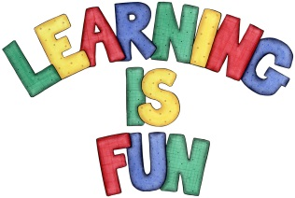
Date Set | 20.11.20
Date Due | 25.11.20
Mathletics | On Matheletics focus on fractions and finding halves of shapes and numbers. Additionally, focus on money and making different amounts using different coins as well as identifying and learning about the pound and pence sign. All activities can be found on matheletics.com. Every child has their username and passwords in their reading records.
Spellodrome  Writing | Your home learning challenge this week is to pretend that you are an explorer that has just stumbled across this house. You need to write a description of the setting using your five senses smell, touch, see. hear and taste to describe and explain:  - Where the house is set e.g. forest, jungle, high up in the mountains etc.?  - What does it look like, smell like, feel like etc.?  - Who might live there and why?  - What did you discover when you arrived there?  - How did you get there?  - Capital letters and full stops.  - Time Connectives, Conjunctions, Adverbs and Verbs  - Be as imaginative and creative as possible and use as many adjectives as you can!!!!  Spellings to learn this week  - camel  - tunnel  - squirrel  - travel  - towel  - tinsel  Over this term please start practising and learning the 2, 5 and 10 times tables and the inverses (division.) There will be a times table challenge every Friday along with the spellings.  If you are confident in these then start on the 3, 4 and 6 times tables.  Homework is due in on Wednesday 25th November 2020.
Reading | Recommended daily reading time:  KS1 20 minutes.
Home Learning Project | Date Set: N/A Date Due:
Greek | Please go to Greek Class Blog for Greek Home Learning  Greek Class - St Cyprian's Greek Orthodox Primary Academy

