YEAR 2 HOME LEARNING
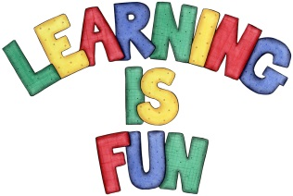
Date Set | 4.12.20
Date Due | 9.12.20
Mathletics | On Matheletics focus on fractions and finding halves of shapes and numbers. Additionally, focus on money and making different amounts using different coins as well as identifying and learning about the pound and pence sign. All activities can be found on matheletics.com. Every child has their username and passwords in their reading records.
Spellodrome  Writing | Your Homework is to write a letter to Santa. You need to share with Santa all of your achievements this year, what you are proud of and what you are thankful for. You also need to include your New Year’s Resolutions and what you would like to achieve next year in 2021!!! You can even illustrate your letter. Remember to include:  - Your address on the top right of the letter (make this up and be as creative as you like)  - Santa’s address (make this up and be as creative as you like)  - Long date  - An opening explaining who you are and why you are writing to Santa  - You must include capital letters, full stops, conjunctions and ensure your sentences make sense  - Write in first person using (I)  - Adjectives to describe your feelings  Spellings to learn this week  - pencil  - fossil  - nostril  - cry  - fly  Over this term please start practising and learning the 2, 5 and 10 times tables and the inverses (division.) There will be a times table challenge every Friday along with the spellings.  If you are confident in these then start on the 3, 4 and 6 times tables.  Homework is due in on Wednesday 9th December 2020.
Reading | Recommended daily reading time:  KS1 20 minutes.
Home Learning Project | Date Set: N/A Date Due:
Greek | Please go to Greek Class Blog for Greek Home Learning  Greek Class - St Cyprian's Greek Orthodox Primary Academy

