YEAR 3 HOME LEARNING
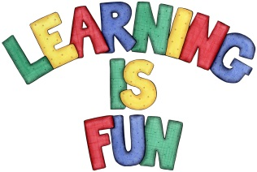
Date Set | 13/11/20
Date Due | 18/11/20
Mathletics | This week, we will be learning how to multiply a 2-digit number by a 1-digit number. We will also be focusing on our times tables.
Spelling  Writing  Home Learning Project | Spellings to learn this week:  - chorus  - scheme  - character  - Christmas  - school  - stomach  - echo  - chemist  - monarch  - chaos  In class we have been reading the adventure story ‘The City of Secret Rivers’ by Jacob Sager Weinstein. The home learning challenge for this week is to create a character profile for one of your favourite adventure stories. You need to include in your writing:  - A description of what they look like  - A description of what they enjoy doing  - A description of how they are feeling  - A description of their personality (what type of person are they?)  - Expanded noun phrases and adjectives  - Sentences that make sense  - Punctuation in the correct places e.g. full stops and capital letters.
Reading | Recommended daily reading time:  KS2 20 minutes.
Home Learning Project | Date Set: Date Due:
Greek | Please go to Greek Class Blog for Greek Home Learning  Greek Class - St Cyprian's Greek Orthodox Primary Academy

