YEAR 3 HOME LEARNING
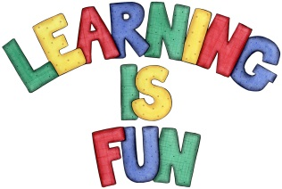
Date Set | 20/11/20
Date Due | 25/11/20
Mathletics | This week, we will be learning how to divide a 2-digit number by a 1-digit number. We will continue focusing on our times tables.
Spelling  Writing  Home Learning Project | Spellings to learn this week:  - myth  - gym  - Egypt  - pyramid  - mystery  - dynasty  - symbol  - synagogue  - mysterious  - mystical  For your writing challenge we would like you to imagine that you are Hyacinth and write a diary entry describing how she feels on her journey. You need to include in your writing:  - ‘I’ when describing what Hyacinth is doing/feelings.  - WOW words to describe her feelings (try to avoid – nice, happy and sad)  - Full stops and capital letters in the correct places.  - Use of sequencing words to describe what is happening next e.g. next, then, after etc.  - Use of because to explain why you are feeling that way.  Write at least a page for your diary entry.  Please bring in a cereal box or a box of similar size by Wednesday 25th November for the children to create 3D models of a river!
Reading | Recommended daily reading time:  KS2 20 minutes.
Home Learning Project | Date Set: Date Due:
Greek | Please go to Greek Class Blog for Greek Home Learning  Greek Class - St Cyprian's Greek Orthodox Primary Academy

