YEAR 3 HOME LEARNING
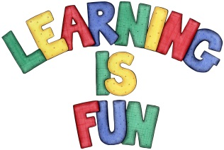
Date Set | 6/11/20
Date Due | 11/11/20
Mathletics | This week will be focusing our 2, 3, 4, 5, 8 and 10 times table as well as using the inverse to answer division questions. We will also be making and learning about properties of 3D Shapes. All activities can be found on matheletics.com. Every child has their username and passwords in their reading records.
Spelling  Writing  Home Learning Project | This week children will be focusing on these words:  - chef  - moustache  - chalet  - parachute  - champagne  - brochure  - crochet  - machine  - ricochet  - chute  Writing Task  In class we will be learning how to use a dictionary, finding meaning of words and writing definitions of words. This week we would like you to put the words below in alphabetical order, use a dictionary to find the meaning of the words and write definitions.  Write each word and definition in the new line e.g.  cheap – adjective  Something that is cheap doesn’t cost very much money.  horrid urge explode sort terrific mischief sloppiness tough gulp dose
Reading | Recommended daily reading time:  KS2 20 minutes.
Home Learning Project | Date Set: Date Due:
Greek | Please go to Greek Class Blog for Greek Home Learning  Greek Class - St Cyprian's Greek Orthodox Primary Academy

