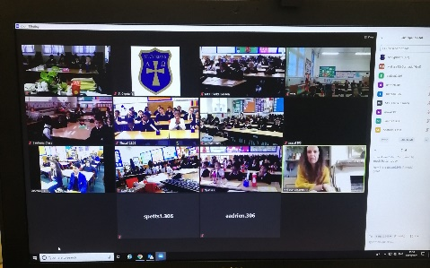
Melissa McCormack
Melissa is an outdoor learning consultant. She teaches children outdoor leaning skills and teaches teachers on how to develop these skills in children. She showed us some of the tools of the trade a knife, flint to light fires and an axe.
She grew up in Scotland then lived in Australia before settling down in Sussex, she now lives in London. She says that if she would give herself any advice when she was young it would be to enjoy everything we do and get outdoors as much as possible. She has dreams of travelling the world with her 3 children.

Roland Jackson
Roland is a journalist who works for AFP. He specialises in business journalism and writes stories on both UK and international news. The stories he writes are then published by media around the world – in newspapers and online news sites.
Roland grew up in Lancaster and completed his postgraduate in newspaper journalism in London where he now works at the London bureau of AFP. He always wanted to be a journalist and his advice to the children was to try to get as much work experience as possible and to never give up, expect to have to keep trying to succeed and preserve in order to fulfil your dreams. He eventually hopes to be a bureau chief of one of the AFP offices somewhere exciting in the world.

Chevanis Green
Chevanis is a cricket participation manager in Surrey. His role is to get people from all backgrounds interested in cricket for example; women in cricket, disadvantaged children and many more. He showed us the Oval Stadium via zoom and spoke about what led him to his career.
Chevanis grew up in Thornton Heath and grew up with a love for cricket. His family are big fans of the West Indies Cricket team and growing up, Chevanis would say, “I want to play for the England team like a West Indies player”. Chevanis went to college and university, after which he began a career in teaching. After teaching for three years, he began training to become a cricket coach and now enjoys inspiring others to get involved. Chevanis now has a dream of making his charity that he has set up successful and left the children with a quote, ‘Do not let the shadow of failure, block the sunlight of success.”

