**HOW TO MAKE A SUNDIAL**

A **sundial** measures time by the position of the sun and usually has markings for each hour of sunlight. **Sundials**have something in the centre which casts a shadow over the markings showing what the time is. For our sundials we will be using a straw, stick or a pencil)

**WHAT YOU NEED**

A sunny spot (outside or by a window)

Pen or chalk

Straw, Stick or another pencil

Plasticine (play doh or blue tack will work too)

**HOW TO MAKE A SIMPLE SUNDIAL**

You’ll need a sunny spot that doesn’t get shady. (Outside in your garden or by a window with direct sunlight). We used plasticine to make the straw stay upright.

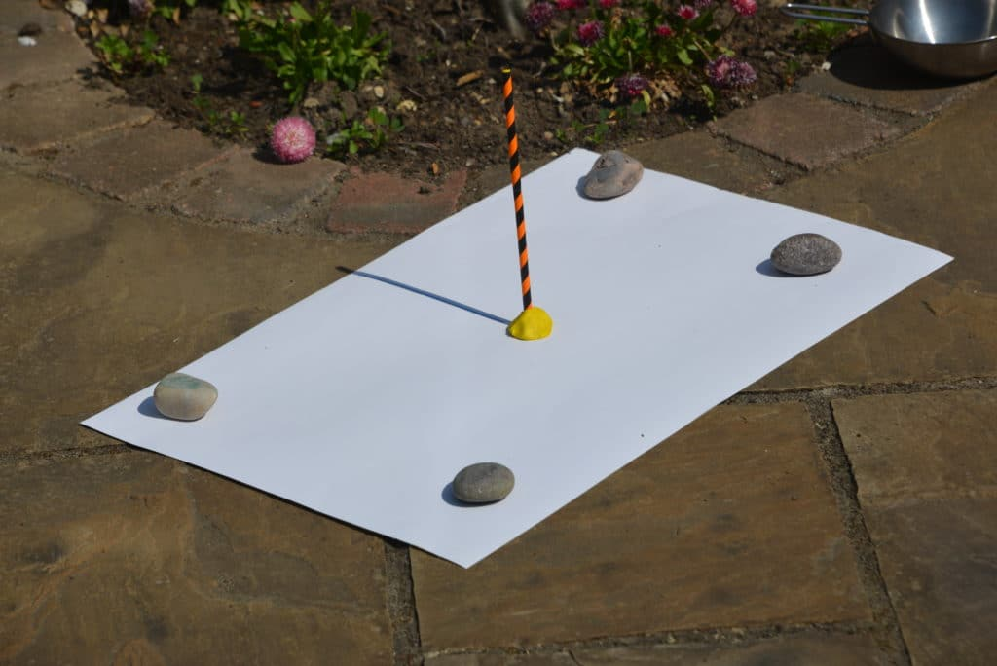

Start your recordings at 9 am tomorrow (Tuesday 8th) and watch as the shadow of the straw changes over the afternoon, marking every hour. As the sun sets quite early these days, try to get your last recording by 3 or 4pm if you can.

When it’s done, it should look something like this.

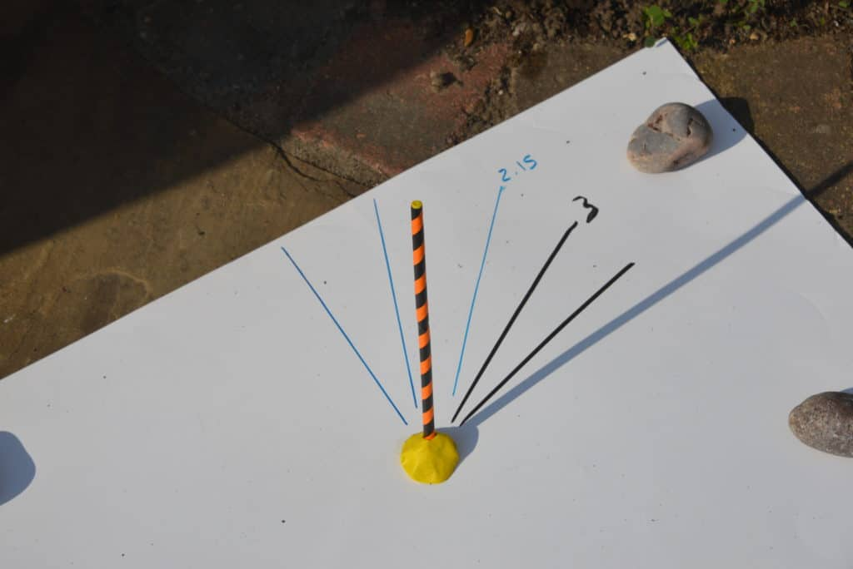

Once, you have done this, write an explanation about what the sun dial tells us about Earth’s movement.

Remember to include key words/phrases:

Rotation, Earth, Sun, shadow, appears to move, movement