YEAR 2 HOME LEARNING
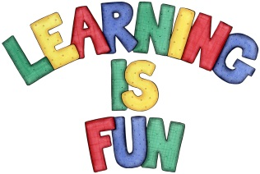
Date Set | 11.12.20
Date Due | 6.1.21
Mathletics | On Matheletics focus on fractions and finding ½, ¼ and ¾  of shapes. Additionally, focus on finding ½ and ¼ of numbers from the multiples of the 2 and 4 times tables. All activities can be found on matheletics.com. Every child has their username and passwords in their reading records.
Spellodrome  Writing | Your homework over the holidays is to research what do humans need to stay healthy. You need to create a booklet or a leaflet once your research is complete. In your writing must include:  - What is a healthy and balanced diet?  - What foods should we eat more of and less of and explain why?  - Research the food pyramid and explain it  - Why is exercise important for our bodies?  - What is personal hygiene and why is it important?  - How do we keep our bodies healthy?  - Why do we need to look after our teeth and how do we do this?  - Headings and Subheadings  - Bullet points  - Photos, diagrams, drawings with captions and labels  Spellings to learn  - copied  - copier  - happier  - happiest  - cried  - replied  - dry  - try  - reply  - July  - flies  - tries  - replies  - copies  - babies  - carries  - wall  - gave  - bread  - boxes  Over this term please start practising and learning the 2, 5 and 10 times tables and the inverses (division.) There will be a times table challenge every Friday along with the spellings. If you are confident in these then start on the 3, 4 and 6 times tables.  Homework is due in on Wednesday 6th January 2021.
Reading | Recommended daily reading time:  Leaflet or Booklet on Healthy Eating  KS1 20 minutes.
Home Learning Project | Date Set: 11.12.20 Date Due: 6.1.21
Greek | Please go to Greek Class Blog for Greek Home Learning  Greek Class - St Cyprian's Greek Orthodox Primary Academy

