YEAR 3 HOME LEARNING
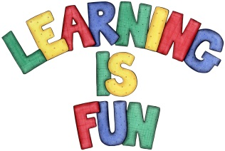
Date Set | 7/12/20
Date Due | 11/12/20
Mathletics | We have been learning to multiply and divide two and three-digit numbers by one- digit number. Practise 2, 3, 4, 5, 8 and 10x tables.
Spelling  Writing | Spellings to learn for the Break:  breath question century popular exercise  famous strange guard guide heart  Writing Task:  In class we have been learning how to use commas in a list. This week we would like you to write a letter to Father Christmas including a wish list as well as the following:  - Your address in the top right hand corner  - The date underneath the address  - An introductory paragraph to explain the purpose of the letter  - Include your wish list using commas  - A final paragraph to conclude the letter  - End with ‘Love from’  Write at least a page.
Reading | Recommended daily reading time:  KS2 20 minutes.
Home Learning Project
Greek | Please go to Greek Class Blog for Greek Home Learning  Greek Class - St Cyprian's Greek Orthodox Primary Academy

