YEAR 3 HOME LEARNING
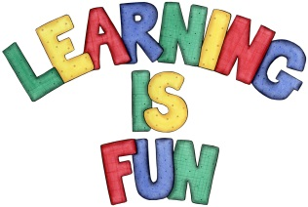
Date Set | 18/12/20
Date Due | 04/01/21
Mathletics | For the break please focus on the 2, 3, 4, 5, 8 and 10-times table as well as using the inverse operation as well as multiplication and division written methods. Feel free to do times tables from 2-12. Practise counting on and back in 1s, 2s, 3s, 4s, 5s, 8s, 10s, 50s, 100s using three digit numbers.
Spelling  Writing | Spellings to learn for the Break:  Please review the spellings that you have learnt this term and make sure that you are confident in these.  Writing Task:  Your writing challenge is to research and investigate how Christmas is celebrated around the world. You can choose any country that you would like to research. You might want to include:  - What do people do to celebrate Christmas?  - Do they have any special traditions that they participate in?  - Where do they go and why?  - Are there any special foods that they might eat?  - You could also include any other interesting information that you find.
Reading | Recommended daily reading time:  KS2 20 minutes.
Home Learning Project | When you return from the break we will be learning about the Prehistoric Britain (Stone Age, Bronze Age and Iron Age). For your home learning project create a poster, leaflet or 3D Art teaching us about the lives of people back in those times. Date due: 08.01.2021
Greek | Please go to Greek Class Blog for Greek Home Learning  Greek Class - St Cyprian's Greek Orthodox Primary Academy

