YEAR 5 HOME LEARNING
Date Set | 26/11/20
Date Due | 2/12/20
Mathletics | Please check mathletics.
Spellings | 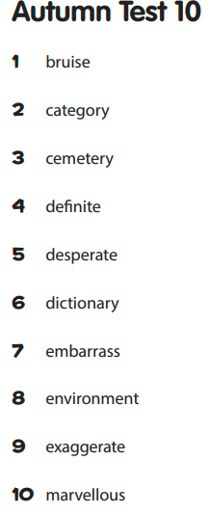  Please also check edshed for extra spelling homework, the children can use their purple mash passwords.
Reading | Recommended daily reading time:  KS2 20 minutes.
Home Learning Project | This week for your home learning, I would like you to pretend that you are an astronaut travelling through outer space. Describe what you see out of the window of your space shuttle. Remember to uses your senses and include descriptive language such as similes and metaphors. This home learning is due Wednesday 16th December 2020.
.Greek | Please go to Greek Class Blog for Greek Home Learning  Greek Class - St Cyprian's Greek Orthodox Primary Academy

