Sources of information about the Maya

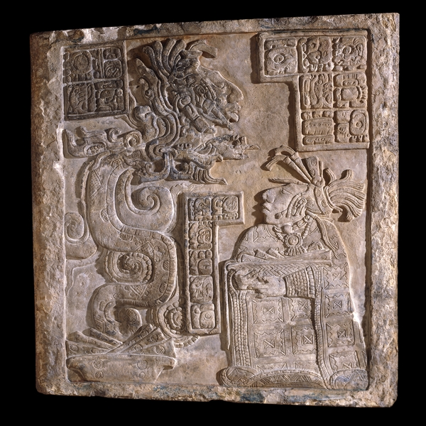
Pictures

There is a woman sitting on the right dressed in woven patterned fabric. She is wearing jewellery around her neck and a big headdress made from feathers, flowers and possibly jade. She carries paper, a rope and some stingray spines, which were used for bloodletting. A snake with a man's head rises up in front of her from a bowl containing strips of paper.

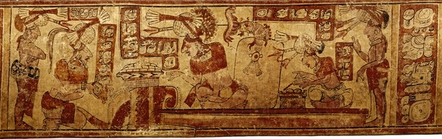
This image shows several men bringing objects to give to the lord, sitting in the middle. All the men are wearing jewellery and elaborate headdresses with flowers and fish. The men seem to have brought maize cakes and cacao pods with them. The man standing on the right is writing what has been brought.
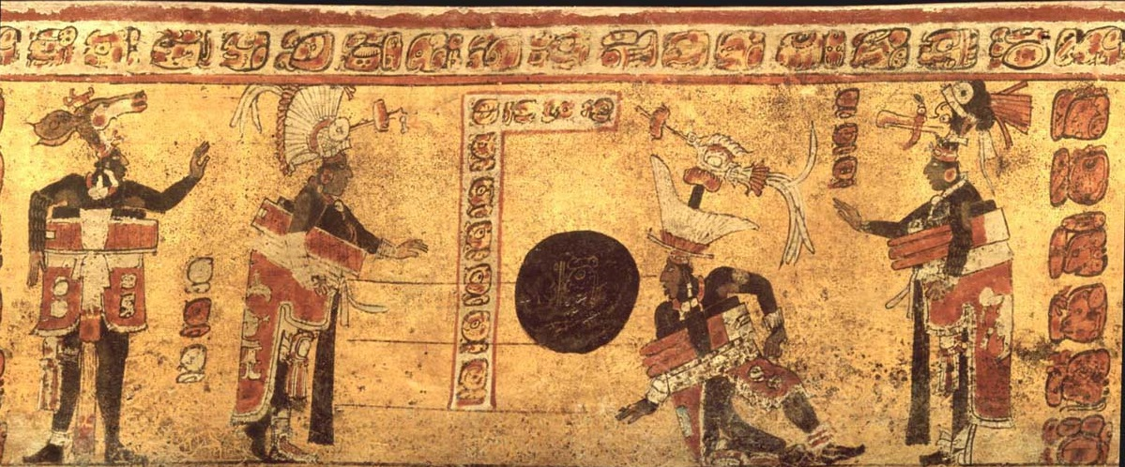
This image shows four ball players in front of some steps. Each player is dressed with padding around their chest to protect them from the ball. They also wear elaborate headdresses, suggesting that the ballgame might not have just been about having fun.

Questions about the pictures:

What kind of clothes are the people wearing?

What events do the pictures show?

In the first picture, do you think the snake is real?

Objects

This object has been carved from stone. It is carved in relief, which means the background is hollowed out to leave the figures standing proud of the surface. The stone is limestone, which is very common around the whole Maya region and is quite a soft stone so easy to carve. It would be carved using other stone tools made of harder stones like flint chisels. Then they would have been smoothed out by running wet sand all over. Traces of paint have also been found, meaning it would have been very colourful originally.

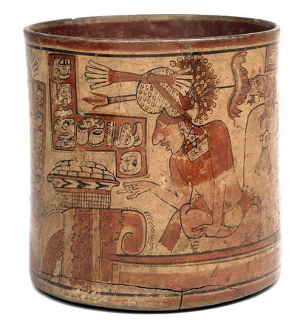
This is a pottery beaker that has been decorated with a slip, which is very watery clay of different colours, and then baked. It was probably used by someone very important and was placed with them in their grave when they died.
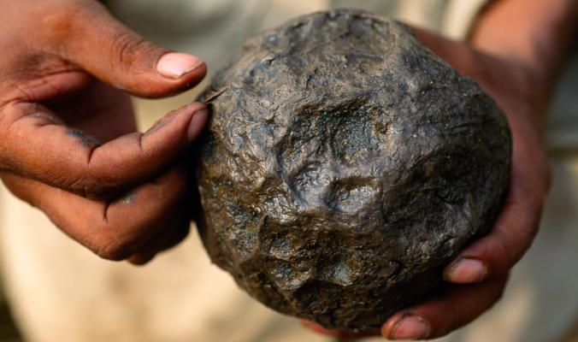
This is the remains of a ball made of latex from the rubber tree that is similar to ones used in a ball game the Maya played. Because it is made of rubber it bounces, and the Maya could combine it with the sap of other plants to make it more or less bouncy.

Questions about the objects:

What kind of skills did the ancient Maya have which you have evidence for in these objects?

What do these objects show about the natural materials available to the Maya?

What do these objects tell us was important to the ancient Maya?

Writing

The writing on this object is carved in the bars. It says that the woman on the right is King Bird Jaguar IV's wife Wak Tuun who was born in what is now known as Motul de San José. The inscription also records the date this was made, in AD 755. It tells us about the bloodletting that she has done, which involves tying stingray barbs onto a rope and them pulling it through a hole in her tongue. The blood is caught in the bowl full of paper she is carrying. Following the bloodletting she is having a vision, seeing an ancestor's ghost she has called on through the mouth of the snake.

The writing in is image is in the red bars. It says that two lords, seated on either side of the king in the middle, bring tribute to the king because he is in charge. The one on the left brings maize cakes (tamales) and the one on the right brings cacao pods.

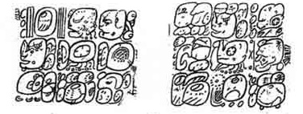
This inscription says “he danced after the ball game, Yax Pasaj Chan Yopaat, the king of the Copan kingdom, the impersonator of Wuk [the old deer god] in the ball game.” This suggests that a king was playing a ball game dressed up as a god and then there was a dance afterwards, perhaps in thanks to the god for winning. This was painted on a pottery vessel from Copan.

Questions about the writing:

Who is mentioned in the writing?

What does the writing tell us about the way of life of the ancient Maya?

What does the writing tell us about the religion of the ancient Maya?

Buildings

This carved stone was a lintel over a doorway in a building in Yaxchilán in Mexico. The building was built by King Bird Jaguar IV as a temple and shows him and his wives and other family members taking part in bloodletting to show how religious they were, as well as strong and unafraid of pain.

This scene probably took place in a palace. The person in the centre is the most important but is still just sitting in the ground, suggesting the Maya did not use chairs. He is sitting on a raised platform, though, to make him look more important than the others. There is a little stone or wood table that a basket has been put on, and possibly a simple door behind the person in the centre.
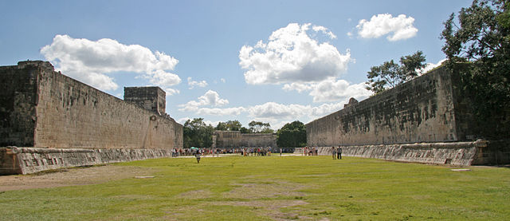
This is a ballcourt at a city called Chichén Itzá. It measures 166 by 68 meters. The walls are 12 metres high, and in the centre, high up on each of the long walls, are rings carved with intertwining serpents.

Questions about the buildings:

What kind of buildings were built by the ancient Maya?

What were the buildings made out of?

What kind of furniture did the ancient Maya have?

