The Maya area

Do some research in books, atlases and online to fill in some detail on this map of Central America.
Can you find out which modern countries the Maya region covers?
Where are the cities, rivers, lakes, etc?

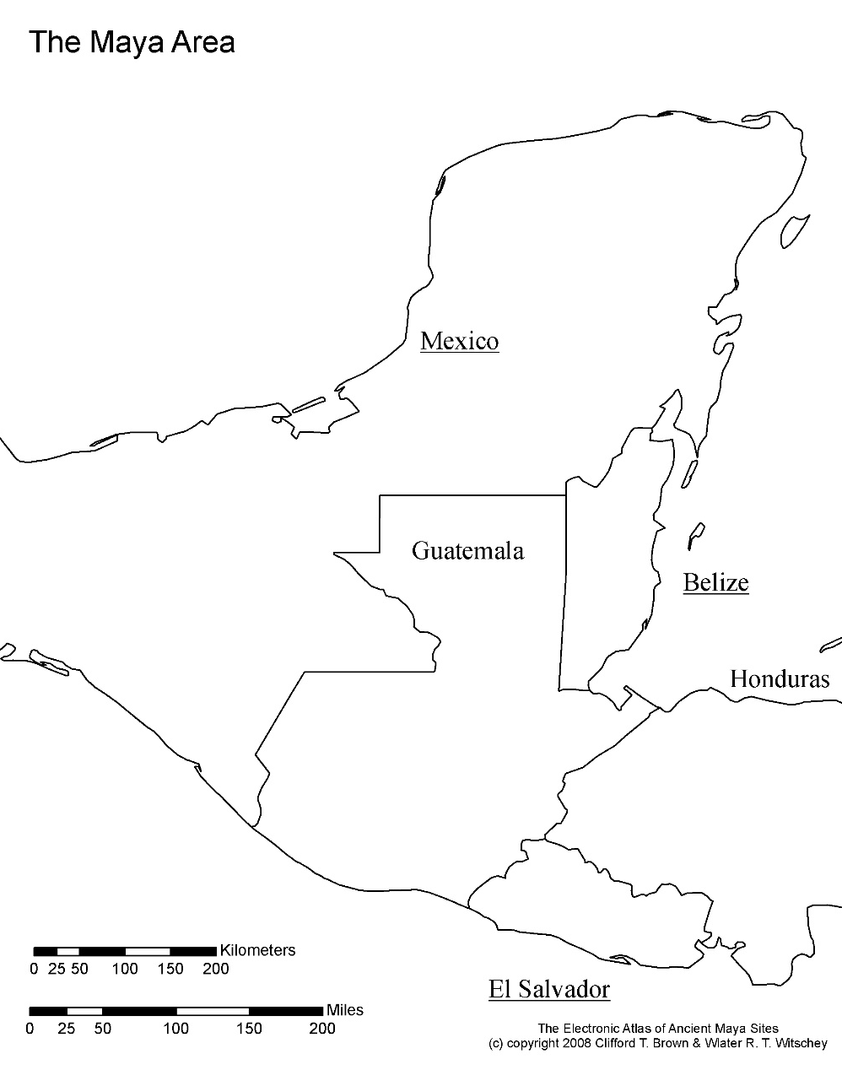

Map of Peru as an example of how to example of how to fill in the details

