YEAR 2 HOME LEARNING
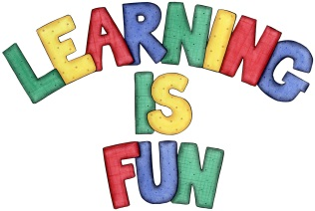
Date Set | 4.1.21
Date Due | 13.1.21
Mathletics | On Matheletics focus on writing simple fractions 1/2, 2/4, 1/4 and 3/4 and finding them in shapes. Also focus on addition and subtraction number bonds. If children are confident in the 2, 5 and 10 times tables please start learning the 3, 4 and 6 times tables. If children are secure in all of the above start learning the 7, 8 and 9 times tables. All activities can be found on matheletics.com. Every child has their username and passwords in their reading records.
Spellodrome  Writing | You home learning is to research a famous sports person who is from the past or present. It could be a footballer, cricketer, athlete, swimmer, gymnast, dancer etc. (you can decide) and write a short biography about them. A biography is a non-fiction piece of writing which is real. It should describe aspects of a person’s life. You must include:  - Brief introduction on who you are writing about  - Why you chose to research them  - Information about their childhood (for example when they were born, where do they live, where did they go to school, do they have any siblings etc.)  - Why they are famous  - Special achievements  - Photo or a drawing including caption  - Capital letters and full stops, time connectives, conjunctions, and paragraphs.  Spellings to learn  • hiking  • hiked  • hiker  • nicer  • nicest  • shiny  Homework is due on Wednesday 13th January 2021.
Reading | Recommended daily reading time:  KS1 20 minutes.
Home Learning Project | Date Set: Date Due:
Greek | Please go to Greek Class Blog for Greek Home Learning  Greek Class - St Cyprian's Greek Orthodox Primary Academy

