YEAR 2 HOME LEARNING
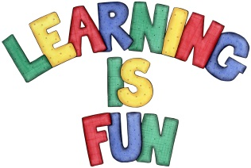
Date Set | 11.1.21
Date Due | 20.1.21
Mathletics | On Matheletics focus on measuring weight using grams and kilograms. If children are confident in the 2, 5 and 10 times tables please start learning the 3, 4 and 6 times tables. All activities can be found on matheletics.com. Every child has their username and passwords in their reading records.
Spellodrome  Writing | For your writing challenge this week read the story of The Three Little Pigs (attached onto the blog.) Then write a character profile for the Big Bad Wolf from The Three Little Pigs in the format of a wanted poster. In your character profile you need to focus on using adjectives, nouns, conjunctions and verbs. In your poster you must also include:  - A drawing of the Big Bad Wolf  - An explanation of why he is blowing the pig’s houses down  - A description of what he looks like  - What does he like to do and his hobbies?  - Where was he seen last e.g. fleeing from the forest or running out of town on a bus.  - Who to contact if The Big Bad Wolf is found?  - Use of connectives to extend your sentences e.g. but, because, then, while, when etc.  - Full stops and capital letters in the correct places.  Spellings to learn this week  - patting  - patted  - humming  - hummed  - dropping  - dropped  Homework is due in on Wednesday 20th January 2021
Reading | Recommended daily reading time:  KS1 20 minutes.
Home Learning Project | Date Set: Date Due:
Greek | Please go to Greek Class Blog for Greek Home Learning  Greek Class - St Cyprian's Greek Orthodox Primary Academy

