YEAR 2 HOME LEARNING
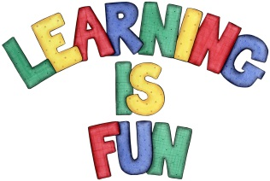
Date Set | 18.1.21
Date Due | 27.1.21
Mathletics | On Matheletics focus on place value and partitioning 2 digit numbers. If children are confident in the 2, 5 and 10 times tables please start learning the 3, 4 and 6 times tables. If children are secure in all of the above start learning the 7, 8 and 9 times tables. All activities can be found on matheletics.com. Every child has their username and passwords in their reading records.
Spellodrome  Writing | For your home learning this week you need to research animals which are either mammals, birds, fish, reptiles, or amphibians. You can choose a group and focus on animals within that group or you could investigate different animals from different groups. You need to create a fact file on them and investigate:  - The lifecycle and a labelled diagram of the mammal, bird, fish, reptile or amphibian you researched  - An explanation of how they change from a baby to an adult  - Information on their diet (including what they eat and what food group they belong to such as herbivore, carnivore and omnivore)  - An explanation of what an herbivore, carnivore and omnivore is  - What is their habitat (E.G forest, ocean, rivers etc) and which country they can be found in?  - Fun Facts about them  - Glossary in alphabetical order with definitions of at least 3 key words  - Labels and captions for photos and drawings  - Use of connectives to extend your sentences e.g. but, because, then, while, when etc.  - Subheadings and Headings  - Full stops and capital letters in the correct places  Spellings to learn this week  - sadder  - saddest  - fatter  - fattest  - runner  - runny  Homework is due on Wednesday 27th January 2021
Reading | Recommended daily reading time:  KS1 20 minutes.
Home Learning Project | Date Set: Date Due:
Greek | Please go to Greek Class Blog for Greek Home Learning  Greek Class - St Cyprian's Greek Orthodox Primary Academy

