YEAR 2 HOME LEARNING
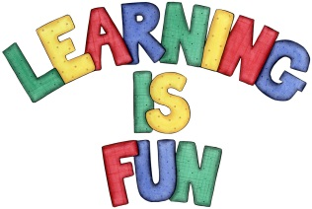
Date Set | 25.1.21
Date Due | 3.2.21
Mathletics | On Matheletics focus on finding the multiples of 5 and 10. Also focus on division and finding the inverse of operations. For example  15 ÷5 = 3 so 3x5=15. If children are confident in the 2, 5 and 10 times tables please start learning the 3, 4 and 6 times tables. If children are secure in all of the above start learning the 7, 8 and 9 times tables. All activities can be found on matheletics.com. Every child has their username and passwords in their reading records.
Spellodrome  Writing | The home learning this week is to research significant Kings and Queens of Britain from the past. You can choose different Kings and Queens and create a booklet about them, or you can choose one King or Queen. Some significant Kings or Queens you might like to research is: Queen Victoria, King Henry VIII (eighth), Queen Mary (Queen of Scots) Queen Elizabeth I (first), King Edward VIII (Eighth), King George VI (sixth).  You must include:  - Introduction explaining what your learning is about (which Kings and Queens you are writing about and why  - An explanation of what the role of a monarch is and their roles and responsibilities  - What is significant or special about your chosen King or Queen  - A short biography about them  - Which Era did they reign in (for example Victorian, Tudors etc)?  - A timeline of their reign with significant events  - What impact did they have on Britain?  - Life during their reign (for example clothes, jobs, houses etc)  - Fun Facts  - Headings and Sub-headings  - Photographs and drawings  - Captions and Labels  - Bullet points and concise sentences with capital letters, full stops, and conjunctions. Please ensure that your sentences make sense.  Spellings to learn this week  - all  - ball  - call  - walk  - talk  - always  Your homework is due in on Wednesday 3rd February 2021.
Reading | Recommended daily reading time:  KS1 20 minutes.
Home Learning Project | Date Set: Date Due:
Greek | Please go to Greek Class Blog for Greek Home Learning  Greek Class - St Cyprian's Greek Orthodox Primary Academy

