YEAR 2 HOME LEARNING
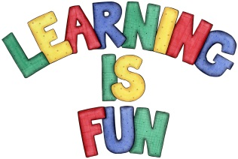
Date Set | 1.2.21
Date Due | 10.2.21
Mathletics | On Matheletics focus on solving multiplication statements and word problems. If children are confident in the 2, 5 and 10 times tables please start learning the 3, 4 and 6 times tables. If children are secure in all of the above start learning the 7, 8 and 9 times tables. All activities can be found on matheletics.com. Every child has their username and passwords in their reading records.
Spellodrome  Writing | For your writing challenge you need to read one of your favourite fairy tales such as Cinderella, Little Red Riding Hood, Goldilocks and the Three Little Bears and Jack and the Beanstalk etc; and re-write the story in your own words. Focus on sequencing your story in the correct order and story language such as Once upon a time or in a faraway land etc.  You need to include in your writing:  - A beginning, middle and end to your story  - A description of the setting (where are the characters-cottage, village etc.)  - Introduction to characters  - Adjectives, time connectives, conjunctions  - Full stops and capital letters in the correct places.  Spellings to learn this week  - pencil  - fossil  - nostril  - cry  - fly  - other  - mother  - brother  - nothing  - Monday  Please start Practising and learning the 2, 5 and 10 times tables. If you are confident in these then start on the 3, 4 and 6 times tables.
Reading | Recommended daily reading time:  KS1 20 minutes.
Home Learning Project | Date Set: Date Due:
Greek | Please go to Greek Class Blog for Greek Home Learning  Greek Class - St Cyprian's Greek Orthodox Primary Academy

