YEAR 3 HOME LEARNING
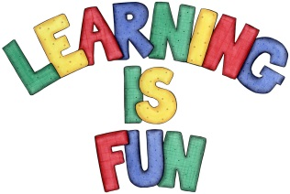
Date Set | 11/01/21
Date Due | 18/01/21
Mathletics | This week we will be focusing on addition and subtraction word problems including two and three-digit numbers. We will be solving addition and subtraction word problems using a column method. Please practice 2, 3, 4, 5, 8 and 10 times tables as well as using the inverse to answer division questions.
Spelling  Writing | This week children will be focusing on these words:  dangerous poisonous cautious curious enormous  delicious courageous anxious devious envious  Writing Task:  Imagine you are a child in the Stone Age. Write a diary entry about your average day. What do you do in the day? What clothes do you wear? What do you eat? Where do you sleep?  Write at least a page.
Reading | Recommended daily reading time:  KS2 40 minutes.
Home Learning Project | Our History topic is Prehistoric Britain (Stone Age, Bronze Age and Iron Age). For your home learning project create a poster, leaflet or 3D Art teaching us about the lives of people back in those times.
Greek | Please go to Greek Class Blog for Greek Home Learning  Greek Class - St Cyprian's Greek Orthodox Primary Academy

