YEAR 3 HOME LEARNING
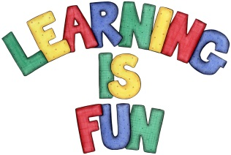
Date Set | 22/02/21
Date Due | 01/03/21
Mathletics | Please focus on calculations using addition and subtraction as well as solving one and two-step word problems. Please practice 2, 3, 4, 5, 8 and 10 times table as well as using the inverse to answer division questions. Practise counting on and back in 1s, 2s, 3s, 4s, 5s, 8s, 10s, 50s and 100s using two and three-digit numbers.
Spelling  Writing | weigh vein eight rein beige neigh neighbour eighty sleigh weight  Writing Task:  This week we would like you to put the words below in alphabetical order, use a dictionary to find the meaning of the words and write definitions. Write each word and definition in the new line e.g.  grow – verb  To grow means to become bigger.  - towering  - unblinking  - wonder  - stilts  - mutton  - gooey  - tremendous  - unfortunately  - glare  - luscious
Reading | Recommended daily reading time:  KS2 40 minutes.
Home Learning Project | Research about magnets and create a poster showing what you have learnt.
Greek | Please go to Greek Class Blog for Greek Home Learning  Greek Class - St Cyprian's Greek Orthodox Primary Academy

