Interpreting Line graphs
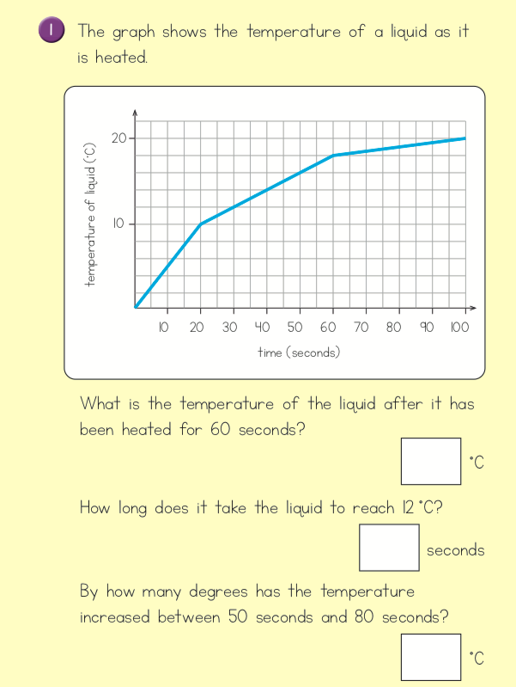

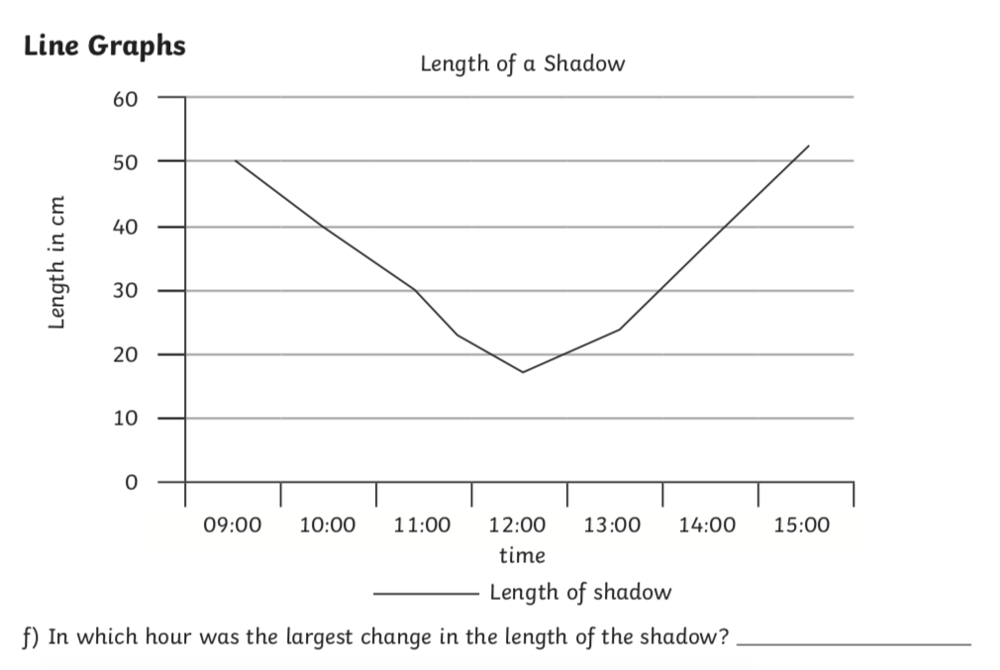

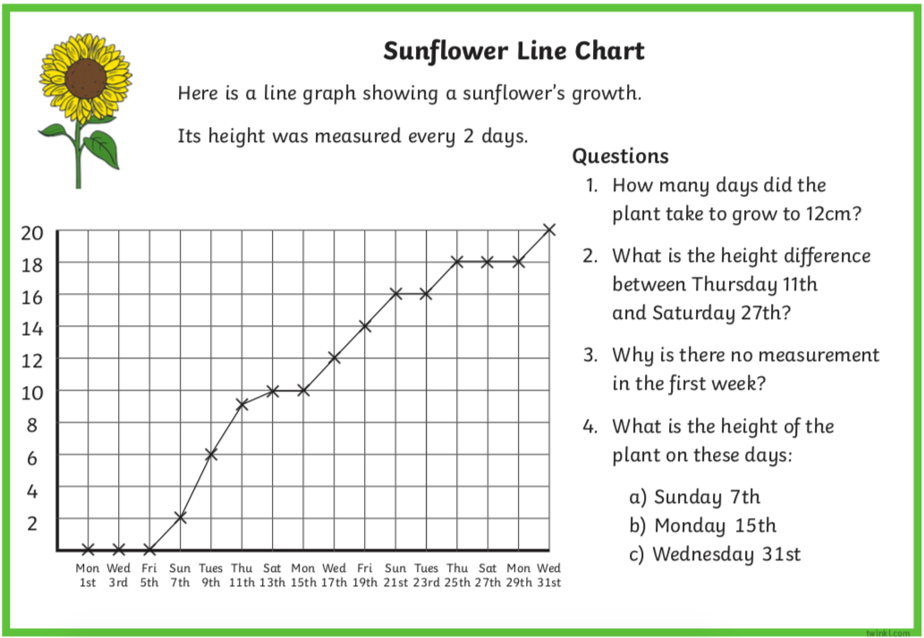

Interpreting Line Graphs
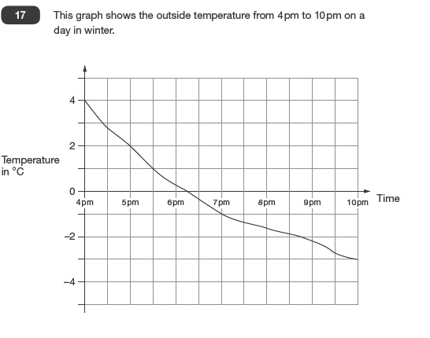

a) What was the lowest temperature recorded on the chart?
b) By how much did the temperature decrease in the first hour?
c) At what time did the temperature reach freezing point?
d) How far did the temperature drop between 4pm and 10pm?
e) Estimate the temperature at 7.30.
f) Estimate the time when the temperature was exactly -2.
g) For how long was the temperature below 0?
h) During which hour did the temperature fall by 2 degrees?
Extension
Draw a table to show the temperature at each hour.

Answers

1a) 18°C b) 30 seconds c) 3°C

2) Between 13:00 and 14:00 (could also accept 13:00)

Sunflower
- 17 days 2. 9cm 3. The plant hadn’t sprouted yet
4. a) 2cm b) 10cm c) 20cm

4a) -3 b) 2°C c) 6:15 d) 7°C e) -1.3/-1.4
f) 8:45pm g) 3 hours and 45 minutes h) from 4 to 5pm

4pm | 4°C
5pm | 2°C
6pm | 0.2°C or 0.3°C
7pm | -1 °C
8pm | -1.5/-1.6
9pm | -2.2°C
10pm | -3

