YEAR 2 HOME LEARNING
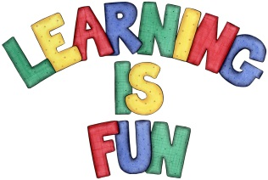
Date Set | 8.2.21
Date Due | 17.2.21
Mathletics | On Matheletics focus on addition and subtraction using number lines and a 100 square. If children are confident in the 2, 5 and 10 times tables please start learning the 3, 4 and 6 times tables. If children are secure in all of the above start learning the 7, 8 and 9 times tables. All activities can be found on matheletics.com. Every child has their username and passwords in their reading records.
Spellodrome  Writing | Your home learning this week is to imagine that you are either the Little Red Riding Hood or the Big Bad Wolf. You need to write a diary entry from the point of view of one of the characters about what you did that day and why. You must include the following:  - Write in first person using ‘I.’  - Explain what happened that day for example taking a basket of delicious cakes to grandma.  - Bumping into the wolf  - How did you feel when you met the wolf?  - What did you do after?  If you are the wolf:  - Why did you go to grandma’s house?  - Why are you an unfriendly wolf?  - Where had you come from before you met Little Red Riding Hood?  - Where did you go next?  Spellings to learn this week  - after  - child  - every  - half  - move  - plant  - whole  Please start Practising and learning the 2, 5 and 10 times tables and the inverses (division.) If you are confident in these then start on the 3, 4 and 6 times tables.
Reading | Recommended daily reading time:  KS1 20 minutes.
Home Learning Project | Date Set: Date Due:
Greek | Please go to Greek Class Blog for Greek Home Learning  Greek Class - St Cyprian's Greek Orthodox Primary Academy

