YEAR 3 HOME LEARNING
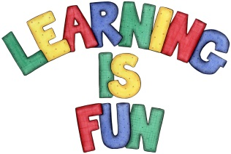
Date Set | 01/02/21
Date Due | 08/02/21
Mathletics | Please focus on calculations using addition and subtraction as well as solving one and two-step word problems. Please practice 2, 3, 4, 5, 8 and 10 times table as well as using the inverse to answer division questions. Practise counting on and back in 1s, 2s, 3s, 4s, 5s, 8s, 10s, 50s and 100s using two and three-digit numbers.
Spelling  Writing | This week children will be focusing on these words:  science scene crescent fascinating ascent  scissors scented scientist descend score  Writing Task:  Your Homework learning challenge this week is to research a Greek Myth. Write a summary about your chosen myth.  It should include:  - the date  - title  - summary  - apostrophes to show contraction and possession  - writing in past.  Write at least a page.
Reading | Recommended daily reading time:  KS2 40 minutes.
Home Learning Project | We are learning about the Prehistoric Britain (Stone Age, Bronze Age and Iron Age). For your home learning project create a poster, leaflet or 3D Art teaching us about the lives of people back in those times.
Greek | Please go to Greek Class Blog for Greek Home Learning  Greek Class - St Cyprian's Greek Orthodox Primary Academy

