YEAR 3 HOME LEARNING
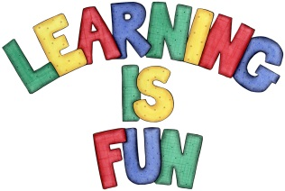
Date Set | 08/02/21
Date Due | 22/02/21
Mathletics | Please focus on calculations using addition and subtraction as well as solving one and two-step word problems. Please practice 2, 3, 4, 5, 8 and 10 times table as well as using the inverse to answer division questions. Practise counting on and back in 1s, 2s, 3s, 4s, 5s, 8s, 10s, 50s and 100s using two and three-digit numbers.
Spelling  Writing | Please review the spellings that you have learnt this half term and make sure that you are confident in these.  Writing Task:  Your Homework learning challenge is to write a book review on one fiction book and one non-fiction book you have read this half term.  It should include:  - the book title  - the author  - was the book fiction or non-fiction  - What was the book about?  - Who would you recommend the book to? Why?  - Book illustration (drawing)  - What ages and interest is this book suitable for? Why?  - What would you rate this book? Lowest 1 2 3 4 5 Highest  Write at least a page.
Reading | Recommended daily reading time:  KS2 40 minutes.
Home Learning Project | Research about magnets and create a poster showing what you have learnt.
Greek | Please go to Greek Class Blog for Greek Home Learning  Greek Class - St Cyprian's Greek Orthodox Primary Academy

