- Be active
- Sing, heads, shoulders, knees and toes or another action song.
- Complete one of the challenges set and complete Miss Maloney’s activity card. Don’t forget you can add any of your own activities, in order to earn your certificates.

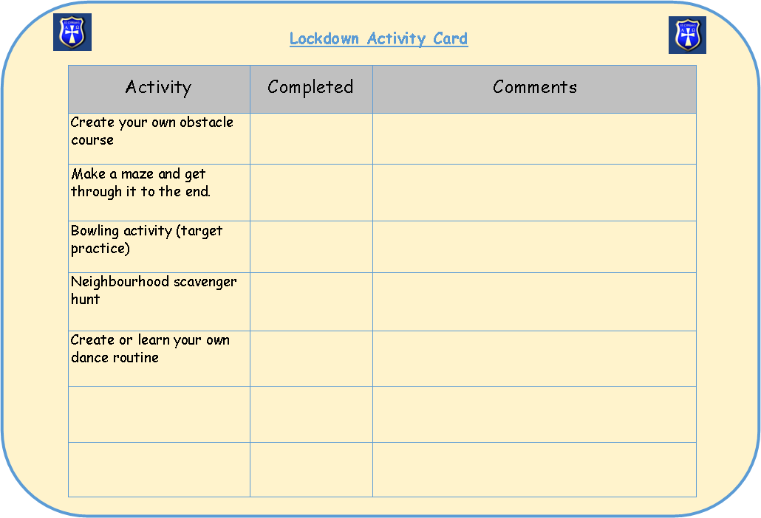

- Go for a walk with your family (in line with COVID guidelines).
- See how many times you can bounce/ catch / kick up a ball.
- Make up a dance routine.
- Play some music you love- sing and dance along.

- Eat well
- Make a fruit kebab by putting a variety of fruits on a stick.
- Make a face using salad or vegetables.
- Help to cook a healthy meal for your family.
- Bake a cake or some biscuits.
- Make a fruit smoothie.

- Feel calm
- Lie down on the floor with an adult, close your eyes and describe a happy time that you shared together.
- Do some yoga together.

- Pamper yourself
- Ask an adult to run you a bubble bath, bring all they water safe toys you have, play with these and have fun in the water.
- Soak your feet and paint your nails.

- Play a game
- Play Kim's game. Find 10 items. Talk about them and then hide them with a cloth. How many can you remember?
- Play a card game.
- Play a board game.
- Hide something in your house and create a treasure hunt for your family to find it.

- Be creative
- Use your recycling waste to create something new.
- Draw or paint a picture.
- Make something using lego.
- Create a dance routine to your favourite piece of music.
- Write your own song and sing it for your family.
- Use objects and create a ramp for your toy car. How far can you make it fly?
- Invent your own board game - link it to something you are learning about at school.
- Make your own comic-strip. Invent your own characters and create their own worlds.
- Think of your favourite book or story and act it out for your family. Would you make a change to the plot? Could you add a funny twist to the story or a shock that your family wouldn't expect?

- Spend time outside
- Pretend to blow out the candles on your birthday cake 5 times and breathe the fresh air in and out.
- Go for a walk, scoot or cycle in the fresh air.
- Sit outside on a night when the sky is clear and look at the stars.
- Go for a walk and take pictures of things that you see.

- Enjoy special time
- Share a goodnight cuddle with an adult while they read you a bedtime story.

- Mindful time
- Tell an adult: 5 things you can see, 4 things you can feel / touch, 3 things you can hear, 2 things you can taste, 1 thing you can smell.
- Draw a picture of what you can see out of your window, or imagine a view from your window. What can you notice, what interests you, what surprises you?

- Sleep well
- Make a dreaming den with a blanket, a pillow and a teddy and have a nap.
- Have a bath and a story before you snuggle down to go to sleep.
- Create a healthy sleeping poster and include some tips for a good night's sleep that you can try.
- Have a hot chocolate and snuggle down with a blanket to read a chapter of your book before you go to bed.

- Be kind
- Give compliments to members of your family.
- Help at home - wash up, dry up, empty the dishwasher, take out the bins or set the table.
- Tidy your bedroom.
- Smile at everyone in your house.
- Phone someone or write a letter to someone who you think might be lonely.

- Connect
- Make a poster of all the people you are thankful for. For example: your parents, your teacher, the post-delivery worker, the people who work in the supermarket, doctors & nurses.
- Write a letter or draw a picture for someone you've not seen recently. Post it to them when you go on a walk to get some exercise with your family.
- Phone someone you miss seeing at the moment and have a good chat about what you've been doing recently.
- List seven things you can do this week to be kind to someone else. Do one thing from your list each day.
- Phone your Grandparents and ask them what school was like when they were young. How was it different to school today?

We would still love to see pictures and hear about what you get up to.

