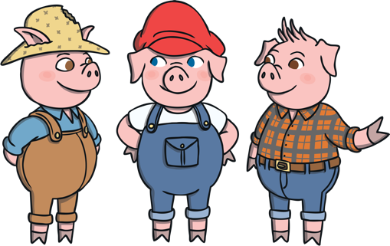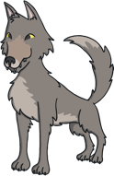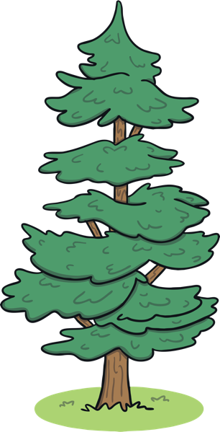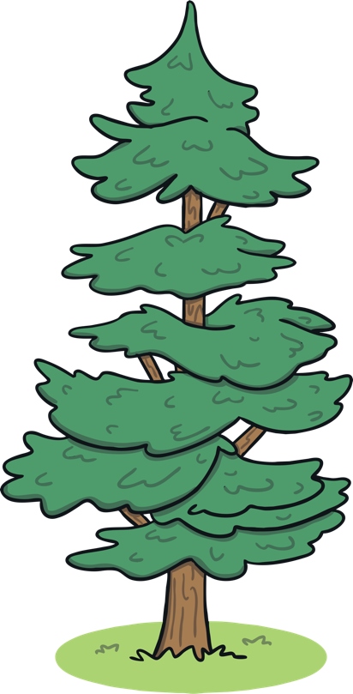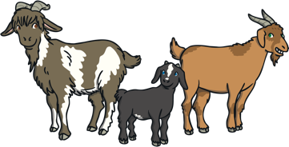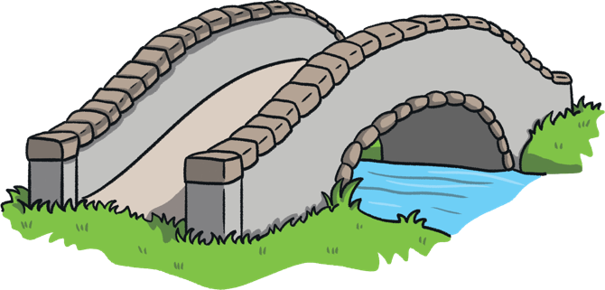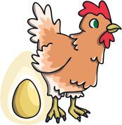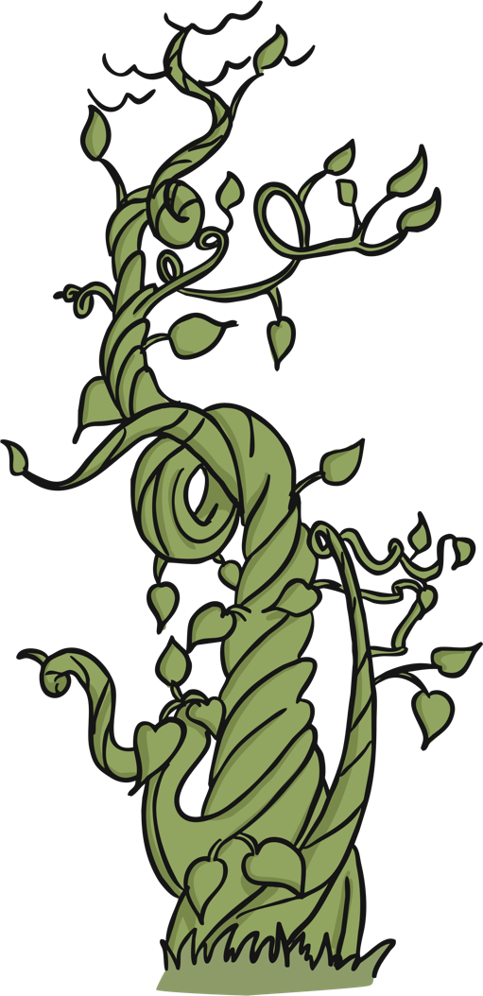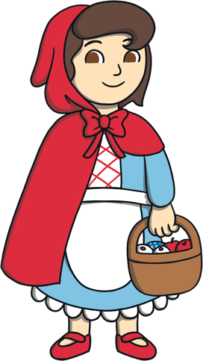

Questions

What can you see near the river?

Which traditional tale has a giant?

Can you see the troll? Where is it?

What has happened to some of the three little pig’s houses?

Which traditional tales could the wolf belong to?

**Traditional Tales**

**‘Can You Find...?’ Poster Instructions**

**Look at the poster. Can you find different things in the picture for these traditional tales?**

Little Red Riding Hood

Jack and the Beanstalk

The Three Billy Goats Gruff

The Gingerbread Man

The Three Little Pigs