YEAR 2 HOME LEARNING
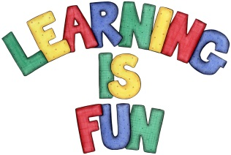
Date Set | 20.3.21
Date Due | 24.3.21
Mathletics | On Matheletics focus on finding fractions of shapes and numbers. Also focus on symmetry of 2D shapes and finding reflective symmetry. If children are confident in the 2, 5 and 10 times tables please start learning the 3, 4 and 6 times tables. All activities can be found on matheletics.com. Every child has their username and passwords in their reading records.
Spellodrome  Writing | Your home learning this week is to research traditional British foods from around the UK. You can choose foods from England, Wales, Scotland and Northern Ireland. You will need to investigate where did your chosen food(s) originate from and write a brief history about your food.  Foods you might like to research are: Shepherd’s Pie, Beef Wellington, Cornish Pasties, Fish and Chips, Afternoon Tea etc. (You can be as creative as you like and could choose other foods which are not included in the list that you might have found. You may choose one country and foods from there or different countries from around the UK with different foods)  You must include:  - An introduction- which country from the UK are you researching food from and why.  - What food(s) have you found and a history about the food  - A recipe for the food you researched  - Photos, drawing and captions  - Headings and Subheadings  Spellings to learn this week  - want  - watch  - wander  - quantity  - squash  Please start Practising and learning the 2, 5 and 10 times tables and the inverses (division.) There will be a times table challenge every Friday along with the spellings.  If you are confident in these then start on the 3, 4 and 6, 7, 8 and 9 times tables.  Homework is due in on Wednesday 24th March 2021
Reading | Recommended daily reading time:  KS1 20 minutes.
Home Learning Project | Date Set: Date Due:
Greek | Please go to Greek Class Blog for Greek Home Learning  Greek Class - St Cyprian's Greek Orthodox Primary Academy

