YEAR 2 HOME LEARNING
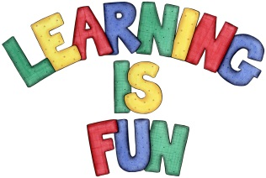
Date Set | 26.3.21
Date Due | 31.3.21
Mathletics | On Matheletics focus on finding Greater than and Less Than. Also focus on the properties of 2D and 3D shapes. If children are confident in the 2, 5 and 10 times tables please start learning the 3, 4 and 6 times tables. All activities can be found on matheletics.com. Every child has their username and passwords in their reading records.
Spellodrome  Writing | Your home learning this week is to make a toy out of recyclable materials. Once you have made your toy you will need to write instructions on how you made your toy. (You can be as creative as you like!) Throughout history toys may have looked different depending on what materials were available to make things from.  In your instructions you must include:  - An introduction to the toy that you have made and give it a name  - Numbered Steps  - Imperative verbs (bossy verbs)  - Capital letters and full stops  - Time Connectives  - A new line for each instruction.  Spellings to learn this week  - door  - wild  - hold  - fast  - bath  - kind  - steak  - half  Please start Practising and learning the 2, 5 and 10 times tables and the inverses (division.) There will be a times table challenge every Friday along with the spellings.  If you are confident in these then start on the 3, 4 and 6, 7, 8 and 9 times tables.  Homework is due in on Wednesday 31st March 2021
Reading | Recommended daily reading time:  KS1 20 minutes.
Home Learning Project | Date Set: Date Due:
Greek | Please go to Greek Class Blog for Greek Home Learning  Greek Class - St Cyprian's Greek Orthodox Primary Academy

