YEAR 3 HOME LEARNING
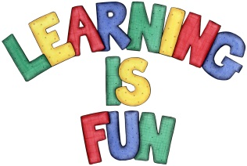
Date Set | 12/03/21
Date Due | 17/03/21
Mathletics | Focus on the 2, 3, 4, 5, 8 and 10-times tables as well as using the inverse operation (multiplication and division written methods). Practise counting on and back in 1s, 2s, 3s, 4s, 5s, 8s, 10s, 50s, 100s using two and three digit numbers.
Spelling  Writing  Home Learning Project | Spellings to learn this week:  - react  - reaction  - reappear  - reassure  - rebuild  - recall  - recook  - recover  - recreate  - recycle  In class we have been reading the book “Around the world in 80 days” by Jules Verne.  For your homework we would like you to imagine you are Phileas Fogg ready to set off on an exciting adventure. What countries would you visit? How would you get there? Who would you take with you? Who would you meet? Write your adventure story and include the following:  - Description of the setting  - Use of senses in your descriptions e.g. what you heard, smelt, saw, touch, tasted etc.  - A beginning, middle and end to your story  - Describing words/ adjectives words throughout your story  - Write in the past tense  - Use of connectives to extend your sentences e.g. but, because, then, while, when etc.  - Full stops and capital letters in the correct places.  Be as creative as possible and write at least a page for your story.
Reading | Recommended daily reading time:  KS2 40 minutes.
Home Learning Project | Research about magnets and create a poster showing what you have learnt.  Date Due: 08/03/21
Greek | Please go to Greek Class Blog for Greek Home Learning  Greek Class - St Cyprian's Greek Orthodox Primary Academy

