YEAR 3 HOME LEARNING
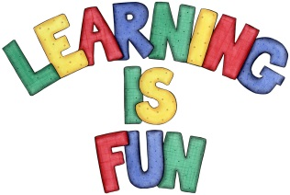
Date Set | 19/03/21
Date Due | 24/03/21
Mathletics | Please focus on calculations using addition and subtraction as well as solving one and two-step word problems. Please practice 2, 3, 4, 5, 8 and 10 times tables and use the inverse to answer division questions. Practise counting on and back in 1s, 2s, 3s, 4s, 5s, 8s, 10s, 50s and 100s using two and three-digit numbers.  The following week we will learn how to interpret and create graphs and charts (tables, pictograms, bar charts).
Spelling  Writing  Home Learning Project | Spellings to learn this week:  - subheading  - subtitle  - submarine  - subtract  - subway  - subject  - submit  - subtotal  - subscribe  - subdivide  For your homework we would like you to create a fact file about the French artist Claude. Monet.  You can include the following:  - Heading  - Full name  - Date and place of birth  - Early life  - Famous for  - Achievements  - Interesting facts and quotes.
Reading | Recommended daily reading time:  KS2 40 minutes.
Home Learning Project | Research about magnets and create a poster showing what you have learnt.  Date Due: 08/03/21
Greek | Please go to Greek Class Blog for Greek Home Learning  Greek Class - St Cyprian's Greek Orthodox Primary Academy

