YEAR 2 HOME LEARNING
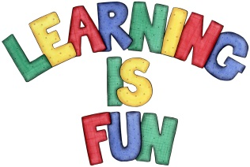
Date Set | 9.4.21
Date Due | 14.4.21
Mathletics | On Matheletics focus on comparing numbers using the more than and less than symbols when ordering and comparing numbers and focus on the properties of 2D and 3D shapes. If children are confident in the 2, 5 and 10 times tables please start learning the 3, 4 and 6 times tables. All activities can be found on matheletics.com. Every child has their username and passwords in their reading records.
Spellodrome  Writing | Your home learning this week is to become historians. You need to research famous landmarks or places from around the UK. You can choose one place or landmark or a few to write about.  Remember to include:  - Introduction: what is your learning about  - What places or landmarks are you writing about?  - A history of the place or landmark  - What is it famous for and why?  - Is there a myth or legend for the place?  - You could also include drawings or photos with captions!  - Remember to use capital letters and full stops  - Write in full sentences  - Check that your sentences make sense  Spellings to learn this week  - cold  - beautiful  - plant  - would  - because  - break  - prove  - any  Please start Practising and learning the 2, 5 and 10 times tables and the inverses (division.) There will be a times table challenge every Friday along with the spellings.  If you are confident in these then start on the 3, 4 and 6, 7, 8 and 9 times tables.  Homework is due in on Wednesday 14th April 2021
Reading | Recommended daily reading time:  KS1 20 minutes.
Home Learning Project | Date Set: Date Due:
Greek | Please go to Greek Class Blog for Greek Home Learning  Greek Class - St Cyprian's Greek Orthodox Primary Academy

