YEAR 2 HOME LEARNING
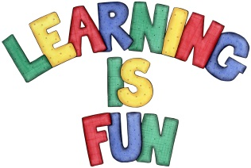
Date Set | 16.4.21
Date Due | 5.5.21
Mathletics | On Matheletics focus on comparing numbers using the more than and less than symbols when ordering and comparing numbers and focus on the properties of 2D and 3D shapes. If children are confident in the 2, 5 and 10 times tables please start learning the 3, 4 and 6 times tables. All activities can be found on matheletics.com. Every child has their username and passwords in their reading records.
Spellodrome  Writing | Your home learning for the holidays is to research a continent and make a booklet about what you have found out. There are seven continents that you can choose from. These are: (Africa, Antarctica, Asia, Australia, Europe, North America and South America.)  You must create a booklet about one of the continents.  In your booklet could include:  - Introduction to your continent  - History about the continent  - What is a continent  - What are the surrounding oceans  - What countries are in the continent  - Famous landmarks from the continent  - Climate  - Population  - Maps  - Drawings  - Fun Facts Box  - Captions and labels  - Anything else you find interesting  Home learning Project:  Your home learning project is to imagine you are stranded on a deserted island. You need to create a shelter out of recyclable materials.  Spellings to learn this week:  - station  - fiction  - motion  - national  - section  Please start Practising and learning the 2, 5 and 10 times tables and the inverses (division.) There will be a times table challenge every Friday along with the spellings.  If you are confident in these then start on the 3, 4 and 6, 7, 8 , 9, 11 and 12 times tables.  Homework is due in on Wednesday 5th May 2021.
Reading | Recommended daily reading time:  KS1 20 minutes.
Home Learning Project | Date Set: Date Due:
Greek | Please go to Greek Class Blog for Greek Home Learning  Greek Class - St Cyprian's Greek Orthodox Primary Academy

