YEAR 3 HOME LEARNING
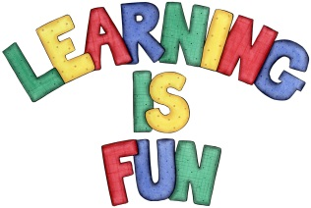
Date Set | 26/03/21
Date Due | 31/03/21
Mathletics | Please focus on calculations using addition and subtraction as well as solving one and two-step word problems. Please practice 2, 3, 4, 5, 8 and 10 times tables and use the inverse to answer division questions. Practise counting on and back in 1s, 2s, 3s, 4s, 5s, 8s, 10s, 50s and 100s using two and three-digit numbers.  The following week we will revise the operation of division and we will learn about halves, quarters and tenths.
Spelling  Writing  Home Learning Project | Spellings to learn this week:  - donation  - adoration  - creation  - animation  - conversation  - dictation  - decoration  - coronation  - duration  - information  For your home learning this week, we would like you to research one of the countries Phileas Fogg visited on his adventure (e.g. China, India, Japan etc.) Create a poster, you may wish to include the following facts:  - Transport  - Climate  - History  - Famous landmarks  - Food  - Animals  - Fun Things to do  - Pictures  - Interesting facts.
Reading | Recommended daily reading time:  KS2 40 minutes.
Home Learning Project | Research about magnets and create a poster showing what you have learnt.  Date Due: 08/03/21
Greek | Please go to Greek Class Blog for Greek Home Learning  Greek Class - St Cyprian's Greek Orthodox Primary Academy

