YEAR 3 HOME LEARNING
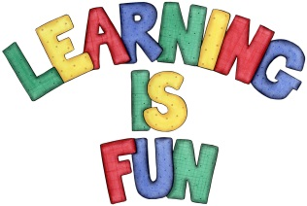
Date Set | 16/04/21
Date Due | 05/05/21
Mathletics | Please focus on calculations using addition and subtraction as well as solving one and two-step word problems. Please practice 2, 3, 4, 5, 8 and 10 times tables and use the inverse to answer division questions. Practise counting on and back in 1s, 2s, 3s, 4s, 5s, 8s, 10s, 50s and 100s using two and three-digit numbers.
Spelling  Writing  Home Learning Project | Spellings to learn this week:  - dangerous  - poisonous  - cautious  - curious  - enormous  - delicious  - courageous  - anxious  - devious  - envious  Your Homework learning challenge is to write a book review on one fiction book and one non-fiction book.  It should include:  - the book title  - the author  - was the book fiction or non-fiction  - What was the book about?  - Who would you recommend the book to? Why?  - Book illustration (drawing)  - What ages and interest is this book suitable for? Why?
Reading | Recommended daily reading time:  KS2 40 minutes.
Home Learning Project | Research about the Stone Age and create a poster showing what you have learnt.  Date Due: 05/05/21
Greek | Please go to Greek Class Blog for Greek Home Learning  Greek Class - St Cyprian's Greek Orthodox Primary Academy

