YEAR 2 HOME LEARNING
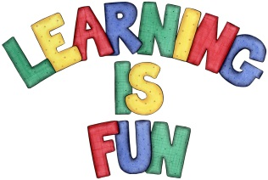
Date Set | 14.5.21
Date Due | 19.5.21
Mathletics | On Matheletics focus on finding fractions of numbers and shapes such as 1/2, 1/4, 2/4, 3/4, 1/3. If children are confident in the 2, 5 and 10 times tables please start learning the 3, 4, 6, 7, 8 and 9 times tables. All activities can be found on matheletics.com. Every child has their username and passwords in their reading records.
Spellodrome  Writing | Your home learning is to research about a famous pirate that has made history! And write a short biography about their life. Some famous pirates you might want to research are: Sir Francis Drake, William Kidd, Blackbeard, Anne Bonney and Black Bart.  In your biography you could include:  - Introduction to your pirate  - Name of the pirate and their nickname if they had one (explaining how they got it.)  - Where did they come from?  - Did they have a ship?  - What was their most famous adventure and why?  - Favourite food or drink  - What did they look like?  - Picture or drawing of the pirate and their ship  - Spellings to learn this week:  - there  - their  - they’re  - here  - hear  - quite  - quiet  - see  - sea  - bare  - bear  Please start Practising and learning the 2, 5 and 10 times tables and the inverses (division.) There will be a times table challenge every Friday along with the spellings.  If you are confident in these then start on the 3, 4 and 6, 7, 8 , 9, 11 and 12 times tables. Homework is due in on Wednesday 19th May 2021.
Reading | Recommended daily reading time:  KS1 20 minutes.
Home Learning Project | Date Set: Date Due:
Greek | Please go to Greek Class Blog for Greek Home Learning  Greek Class - St Cyprian's Greek Orthodox Primary Academy

