YEAR 3 HOME LEARNING
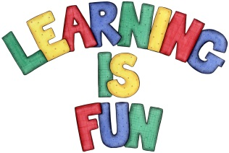
Date Set | 07/05/21
Date Due | 12/05/21
Mathletics | Please focus on calculations using addition and subtraction as well as solving one and two-step word problems. Please practice 2, 3, 4, 5, 8 and 10 times tables and use the inverse to answer division questions. Practise counting on and back in 1s, 2s, 3s, 4s, 5s, 8s, 10s, 50s and 100s using two and three-digit numbers.  Please practice on two-digit number by one-digit number divisions with remainders using the bus stop method.  This week we will learn about fractions (tenths, fractions of a set of objects/number, equivalent fractions).
Spelling  Writing  Home Learning Project | Spellings to learn this week:  - weigh  - vein  - eight  - rein  - beige  - neigh  - neighbour  - eighty  - sleigh  - weight  Your Homework learning challenge this week is to write a recipe for your favourite food. You need to include the following:  - Photo of your favourite food  - Instructions on how to cook your favourite dish  - Imperative verbs, Adverbs and Time Connectives  - You could also include what part of the world your cuisine is from and why is it your favourite dish.
Reading | Recommended daily reading time:  KS2 40 minutes.
Home Learning Project | Research about the Stone Age and create a poster showing what you have learnt.  Date Due: 05/05/21
Greek | Please go to Greek Class Blog for Greek Home Learning  Greek Class - St Cyprian's Greek Orthodox Primary Academy

