YEAR 3 HOME LEARNING
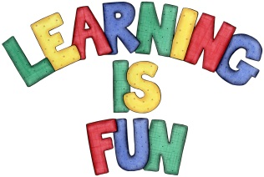
Date Set | 14/05/21
Date Due | 19/05/21
Mathletics | Please focus on calculations using addition and subtraction as well as solving one and two-step word problems. Please practice 2, 3, 4, 5, 8 and 10 times tables and use the inverse to answer division questions. Practise counting on and back in 1s, 2s, 3s, 4s, 5s, 8s, 10s, 50s and 100s using two and three-digit numbers.  This week we will learn about fractions (equivalent fractions, adding, subtracting and ordering fractions).
Spelling  Writing  Home Learning Project | Spellings to learn this week:  - science  - scene  - crescent  - fascinating  - ascent  - scissors  - scented  - scientist  - descend  - score  Your Homework learning challenge this week is to imagine you are a child in the Stone Age. Write a diary entry about your average day. What do you do in the day? What clothes do you wear? What do you eat? Where do you sleep?
Reading | Recommended daily reading time:  KS2 40 minutes.
Home Learning Project | Research about the Stone Age and create a poster showing what you have learnt.  Date Due: 05/05/21
Greek | Please go to Greek Class Blog for Greek Home Learning  Greek Class - St Cyprian's Greek Orthodox Primary Academy

