YEAR 2 HOME LEARNING
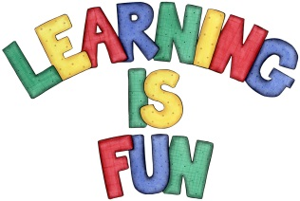
Date Set | 4.6.21
Date Due | 16.6.21
Mathletics | On Mathletics focus on time and reading the clock at o’clock, quarter past, quarter to. Half past and 5-minute intervals. If children are confident in the 2, 5- and 10-times tables please start learning the 3, 4, 6, 7, 8- and 9-times tables. All activities can be found on matheletics.com. Every child has their username and passwords in their reading records.
Spellodrome  Writing | Throughout history there have been extraordinary people who have helped society. Your home learning this week is to choose a person that you feel has made a difference to our world and make a leaflet about them. It could be somebody from the past or somebody from the present such as: Captain Tom Moore, Charles Darwin, Christopher Columbus, Anne Frank, Emmeline Pankhurst, Gandhi, Elon Musk, Michael Jackson etc. You can choose!!  In your leaflet remember to include:  - Introduction to person  - DOB (Date of Birth)  - Information about their life  - What are they famous for and why  - Awards  - Fun Facts that you have learnt about them  - Pictures, Captions, Subheadings  For your home learning project, draw an A4 portrait of the person that you feel has made a difference to our world.  Spellings to learn this week  - climb  - only  - old  - gold  - told  - everybody  - most  - both  - cold  - hold  - every  Please start Practising and learning the 2, 5 and 10 times tables and the inverses (division.) There will be a times table challenge every Friday along with the spellings.  If you are confident in these then start on the 3, 4 and 6, 7, 8 , 9, 11 and 12 times tables. Homework is due in on Wednesday 16th June 2021.
Reading | Recommended daily reading time:  KS1 20 minutes.
Home Learning Project | Date Set: Date Due:
Greek | Please go to Greek Class Blog for Greek Home Learning  Greek Class - St Cyprian's Greek Orthodox Primary Academy

