YEAR HOME LEARNING
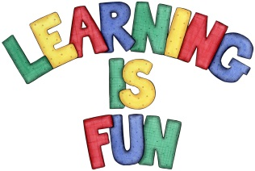
Date Set | 08.10.2021
Date Due | 13.10.2021
Maths | The children have been assigned 4 tasks on Purple Mash. These will close on Wednesday.
Spelling  Writing | existence frequently identity language  explanation government immediately leisure  familiar guarantee individual lightning  foreign harass interfere marvellous  forty hindrance interrupt mischievous  The children will be tested on Thursday.  Writing Task  This week we would like you to write us a diary entry about when you met Joe Wicks in school this week. We would like you to explain about how you felt and how he has inspired you.
Reading | Recommended daily reading time:  KS1 15-20 minutes.  KS2 40 minutes.
Greek | Please go to Greek Class Blog for Greek Home Learning  Greek Class - St Cyprian's Greek Orthodox Primary Academy

