YEAR 5 HOME LEARNING
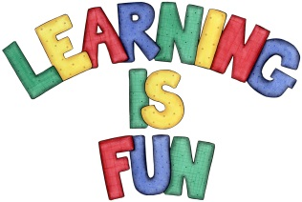
Date Set | 22.10.2021
Date Due | 1.11.2021
Maths | The children have been assigned Maths tasks on edshed https://www.edshed.com . The passwords for these accounts are the same as your Purple Mash passwords.
Spelling  Writing | rhyme signature system twelfth  rhythm sincerely suggest variety  sacrifice soldier symbol vegetable  secretary stomach temperature vehicle  shoulder sufficient thorough yacht  The children will be tested on Wednesday when we return to school.  Writing Task  This week we would like you to write us step by step instructions telling us how to make a jam sandwich. Please try to use the same words that you have been including in your writing this week at school. Here are some examples First of all, then , afterwards and finally.
Reading | Recommended daily reading time:  KS1 15-20 minutes.  KS2 40 minutes.
Greek | Please go to Greek Class Blog for Greek Home Learning  Greek Class - St Cyprian's Greek Orthodox Primary Academy

