YEAR HOME LEARNING
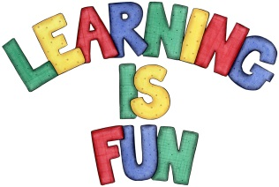
Date Set | 05.11.2021
Date Due | 10.11.2021
Maths | The children have been assigned tasks on EdShed.
Spelling  Writing | This week we would like you to learn words that end in ious and cious.  ambitious amphibious delicious luscious  infectious curious atrocious malicious  fictitious devious conscious precious  nutritious notorious ferocious spacious  repetitious obvious gracious suspicious  The children will be tested on Wednesday.  Writing Task  Please can you write 10 sentences using brackets, commas and dashes, to indicate parenthesis.  Note to parents: Parenthesis is a word, phrase or sentence that is put in writing as extra information or an afterthought. If you took the parenthesis away, the passage would still be complete without it.
Reading | Recommended daily reading time:  KS1 15-20 minutes.  KS2 40 minutes.
Greek | Please go to Greek Class Blog for Greek Home Learning  Greek Class - St Cyprian's Greek Orthodox Primary Academy

