YEAR 5 HOME LEARNING
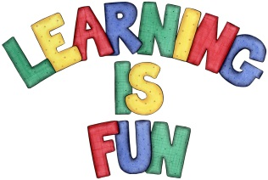
Date Set | 03.12.21
Date Due | 08.12.21
Maths | The children have been assigned Maths tasks on edshed https://www.edshed.com . The passwords for these accounts are the same as your Purple Mash passwords.
Spelling  Writing | abundance hesitancy innocence competence  brilliance relevancy decent transparent  elegance vacancy frequent eloquence  extravagance dominancy emergent violent  tolerance abundancy confidence intelligence  The children will be tested on Wednesday 8th December.  Writing Task  This week we would like you to write a recount about the circus workshop that you you attended. What skills did this workshop help you develop? Can you use these skills in your life outside school? Can you think of some examples?
Reading | Recommended daily reading time:  KS1 15-20 minutes.  KS2 40 minutes.
Greek | Please go to Greek Class Blog for Greek Home Learning  Greek Class - St Cyprian's Greek Orthodox Primary Academy

