YEAR HOME LEARNING
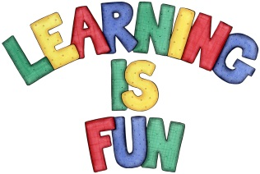
Date Set | 28.01.22
Date Due | 02.02.22
Maths | Please look on Edshed for this week’s work:  - Ordering numbers
Spelling  Writing | Please look at Ed Shed for the spelling challenge for the week:  Words with the long /a/ sound spelled ei:  - vein  - weigh  - eight  - neighbour  - sleigh  - reign  - freight  - reins  - veil  - eighteen  For your home learning this weekend, we would like you to write an adventure story about a child who has lost their home in the eruption of Pompeii. They managed to get out safely with their family but all their possessions are lost. Write about their experiences and how they managed to get to their new homes.
Reading | Recommended daily reading time:  KS2 20 minutes.
Greek | Please go to Greek Class Blog for Greek Home Learning  Greek Class - St Cyprian's Greek Orthodox Primary Academy

