Reception
HOME LEARNING
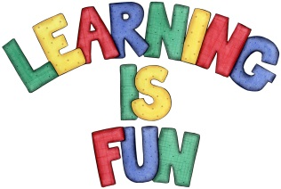
Date Set | 17.02.22
Date Due | 04.03.22
Reading | - Please sign and/ or write a comment on how your child is getting along.  - On Monday morning, your child will share the reading record and book with their teacher. The teacher will acknowledge the comment/ signature with a stamp, signature or comment.  - Your child will then have their book changed.  Please note, if we don’t receive the book or see a comment we will not change for a new book.
Home Learning Project | Hand in date: Friday 4th March 2022  Learning: to research about the seasons.  Your task is to use the internet and the library to research facts and information about the new season coming, Spring. Try to find information about the season such as weather, what the people wear in Spring, and what happen with flowers and trees at rhis season.  You can make a 3D poster, or be creative and show your learning in another way (no bigger than A3). Please try to put the information into your own words, and not directly copy from books or the internet.  We look forward to seeing your completed projects. Good luck!

