YEAR 5 HOME LEARNING
Date Set | 01.04.2022
Date Due | 31.03.2022
Spelling  Writing | 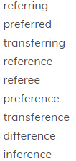  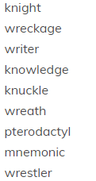  The children will be tested on Friday 8th April.  Those scoring less than 5 will have the opportunity to retest.  Writing task is to create a diary entry, being a follower of Jesus in his last days. Explain what has been happening and how you are feeling towards all that has occurred.
Reading | Recommended daily reading time:  KS1 15-20 minutes.  KS2 40 minutes.  Work is also uploaded on Edshed
Greek | Please go to Greek Class Blog for Greek Home Learning  Greek Class - St Cyprian's Greek Orthodox Primary Academy

