YEAR 3 HOME LEARNING
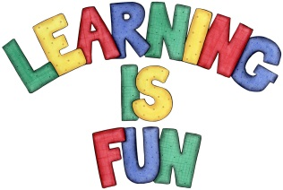
Date Set | 13.05.22
Date Due | 18.05.22
Maths | Please look on Ed shed for this week’s work:  - Mixed multiplication and division
Spelling  Writing | Please look at Ed Shed for the spelling challenge for the week:  Homophones:  - grate  - great  - groan  - grown  - main  - mane  - meat  - meet  - missed  - mist  For your writing this week, I would like you to write a set of instructions. It can be about anything you want. From how to bake a cake, to how to play a certain game. Make it as creative as you want. You can even make up a silly recipe if want. Your instructions should include:  - An introduction explaining what the instructions are for.  - What is needed  - Numbered steps  - Imperative verbs (Chop, cut, draw)  - You can also try to use modal verbs. (might, could, should)
Reading | Required daily reading time:  KS2 20 minutes.
Greek | Please go to Greek Class Blog for Greek Home Learning  Greek Class - St Cyprian's Greek Orthodox Primary Academy

