YEAR 1 HOME LEARNING
Date Set | 18.11.22
Date Due | 23.11.22
Maths | Please log onto EdShed (https://www.edshed.com/en-gb/login) where you will find your maths home learning under assignments. Good luck!
Spelling  Writing | Please check EdShed for some phonics activities.  Writing Task  Can you draw a picture of your favourite character from Katie in London? You can draw more than one character if you like. When you have finished, you can use your sounds to label the characters. Don’t forget, names have capital letters! If you can, write some sentences on what you like about the story so far!  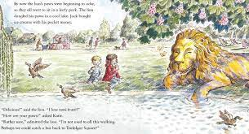  Parents, the characters are called Katie, Jack, Lion and Grandma.
Reading | Recommended daily reading time:  KS1 15 minutes
Greek | Please go to Greek Class Blog for Greek Home Learning  Greek Class - St Cyprian's Greek Orthodox Primary Academy

