YEAR 4 HOME LEARNING
Date Set | 10.03.23
Date Due | 15.03.23
Maths | Please log onto EdShed (https://www.edshed.com/en-gb/login) where you will find your maths home learning under assignments. Good luck!
Spelling  Writing | Please log onto EdShed (https://www.edshed.com/en-gb/login) where you will find your spelling home learning under assignments.  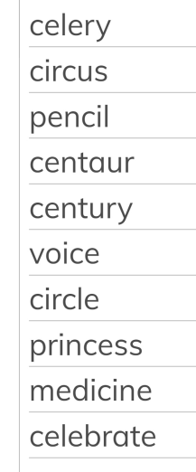  Writing Task  Write a paragraph about the Main Character’s (MC) relative who has been in Egypt and is now ill. Write at least one sentence about when the relative became sick. Write at least one sentence about what happened when the MC tried to solve the mystery and had to leave the pyramid quickly.
Reading | Recommended daily reading time:  KS2 40 minutes.
Greek | Please go to Greek Class Blog for Greek Home Learning  Greek Class - St Cyprian's Greek Orthodox Primary Academy

