YEAR 4 HOME LEARNING
Date Set | 03.03.23
Date Due | 08.03.23
Maths | Please log onto EdShed (https://www.edshed.com/en-gb/login) where you will find your maths home learning under assignments. Good luck!
Spelling  Writing | Please log onto EdShed (https://www.edshed.com/en-gb/login) where you will find your spelling home learning under assignments.  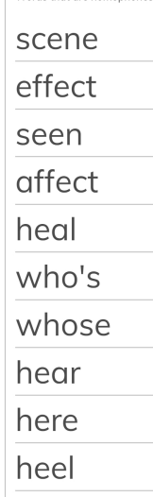  Writing Task  Write a list of verbs and adverbs and/or similes to describe your character moving away from the threat. You could also describe how the threat moves.  For example: Lara ran as fast as lightning while the jackal inched its way through the shadows towards her.
Reading | Recommended daily reading time:  KS2 40 minutes.
Greek | Please go to Greek Class Blog for Greek Home Learning  Greek Class - St Cyprian's Greek Orthodox Primary Academy

